
Earth Day 2008 Lake Clean UP for Carter Lake

When: Saturday, April 19, 2008 from 8:00 –12:00 NOON.

Where: Volunteer Central at Mabrey Park at 17th and Willow Drive in Carter Lake, Iowa

Food: Breakfast and Lunch will be served at Mabrey Park in Carter Lake.

Map and Directions:
From Locust Street: Turn Right (north) on 13th Street. Turn right (east) onto Willow Drive. The Mabrey Park is at Willow Drive and North 17th Street.

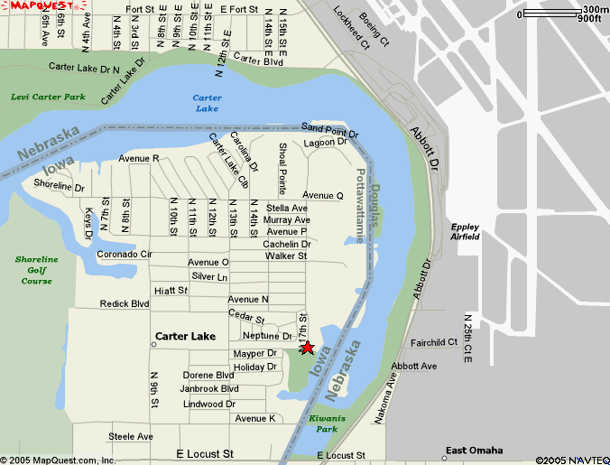

Volunteer Expectations
Volunteers will be assigned to a team that will have a specific area of the lake and city park to pick up trash and recyclables. Breakfast and lunch will be served.
- Wear sturdy shoes and long pants to cover legs to protect from scratches from weeds
- Dress for the weather.
- Plastic and leather gloves will be available (while supply lasts).
- Bring hand garden tools to pick up trash.

Registration
- Read and sign waiver, register, get name tags. You will be assigned a team to work in a specific area and will walk the beaches and pick up trash, meet team captain and get bags.

For Questions, Contact:
carterlake@hotmail.com or Jeanne Eibes @ 712-347-6455

Power of One Service Project: The Carter Lake Preservation Society is partnering with the Earth Day Omaha Coalition "Power of One Service Project" on Earth Day, Saturday, April 19, 2008. Volunteers will clean Levi Carter Park, Kiwanis Park and Pond as well as the Lake Shore around Carter Lake.

