Current Lake Level Controls
Water Out : North Flood Control Lift Station

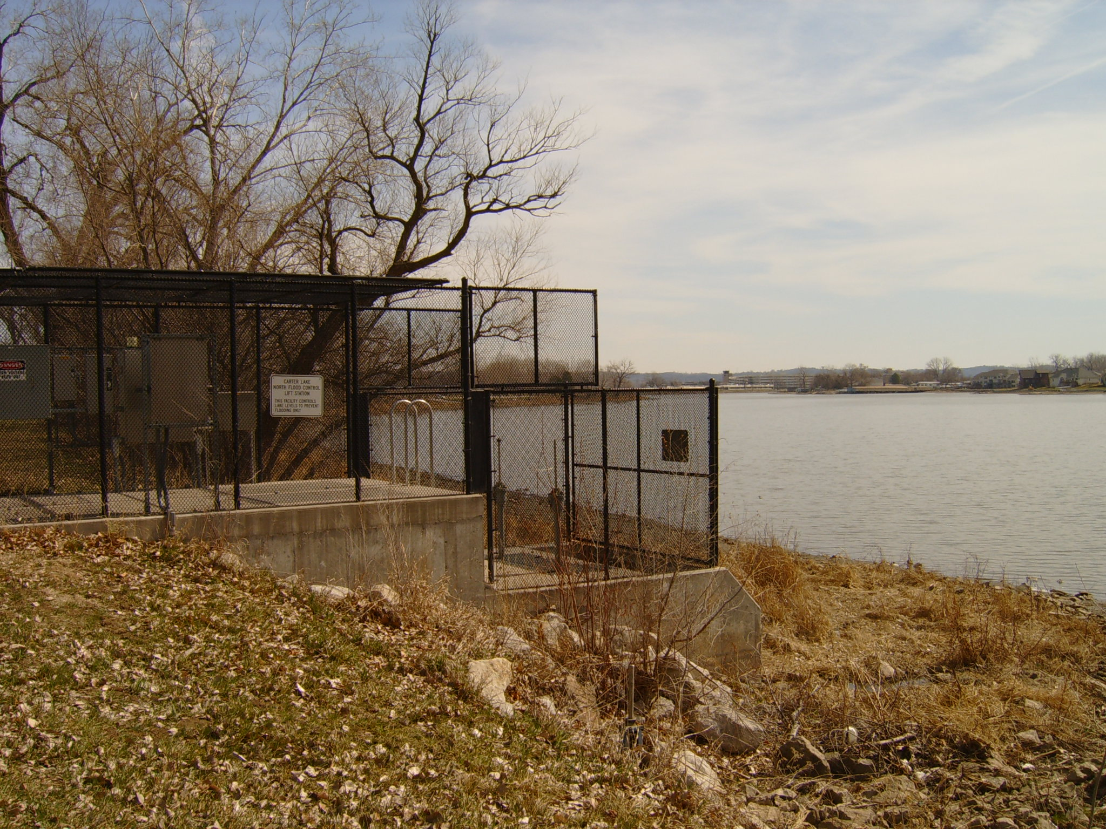
In 1998-99, the cities of Omaha and Carter Lake constructed the North Flood Control Lift Station.

This facility is equipped with two pumps with a capacity of 4,500 gallon per minute each. These pumps are used to control the lake level in the event of a flood.

These pumps have the capacity to drain the lake 1.5 feet in less than 10 days in the event of a significant rain event such as the August, 1999 eleven inch rain event.
Carter Lake North Flood Control Lift Station
Water In : Missouri River Barge Canal

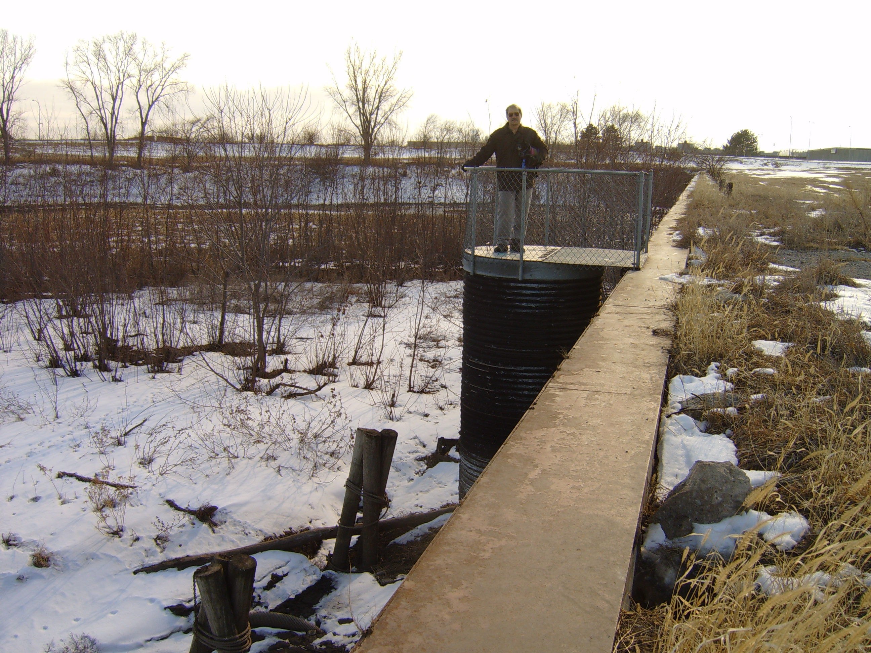
In 1989-90, a small pump was used to bring surface water from the Missouri River Barge Canal to the Lake via the Storz Street pumping station.

This pump was used only once during the summer of 1990.

The barge canal eventually silted in. The pump was removed and this system is no longer useable, however, the piping is still in place.
Abandoned Missouri River Barge Canal Pump
Water In : Kiwanis Park Pond and Well

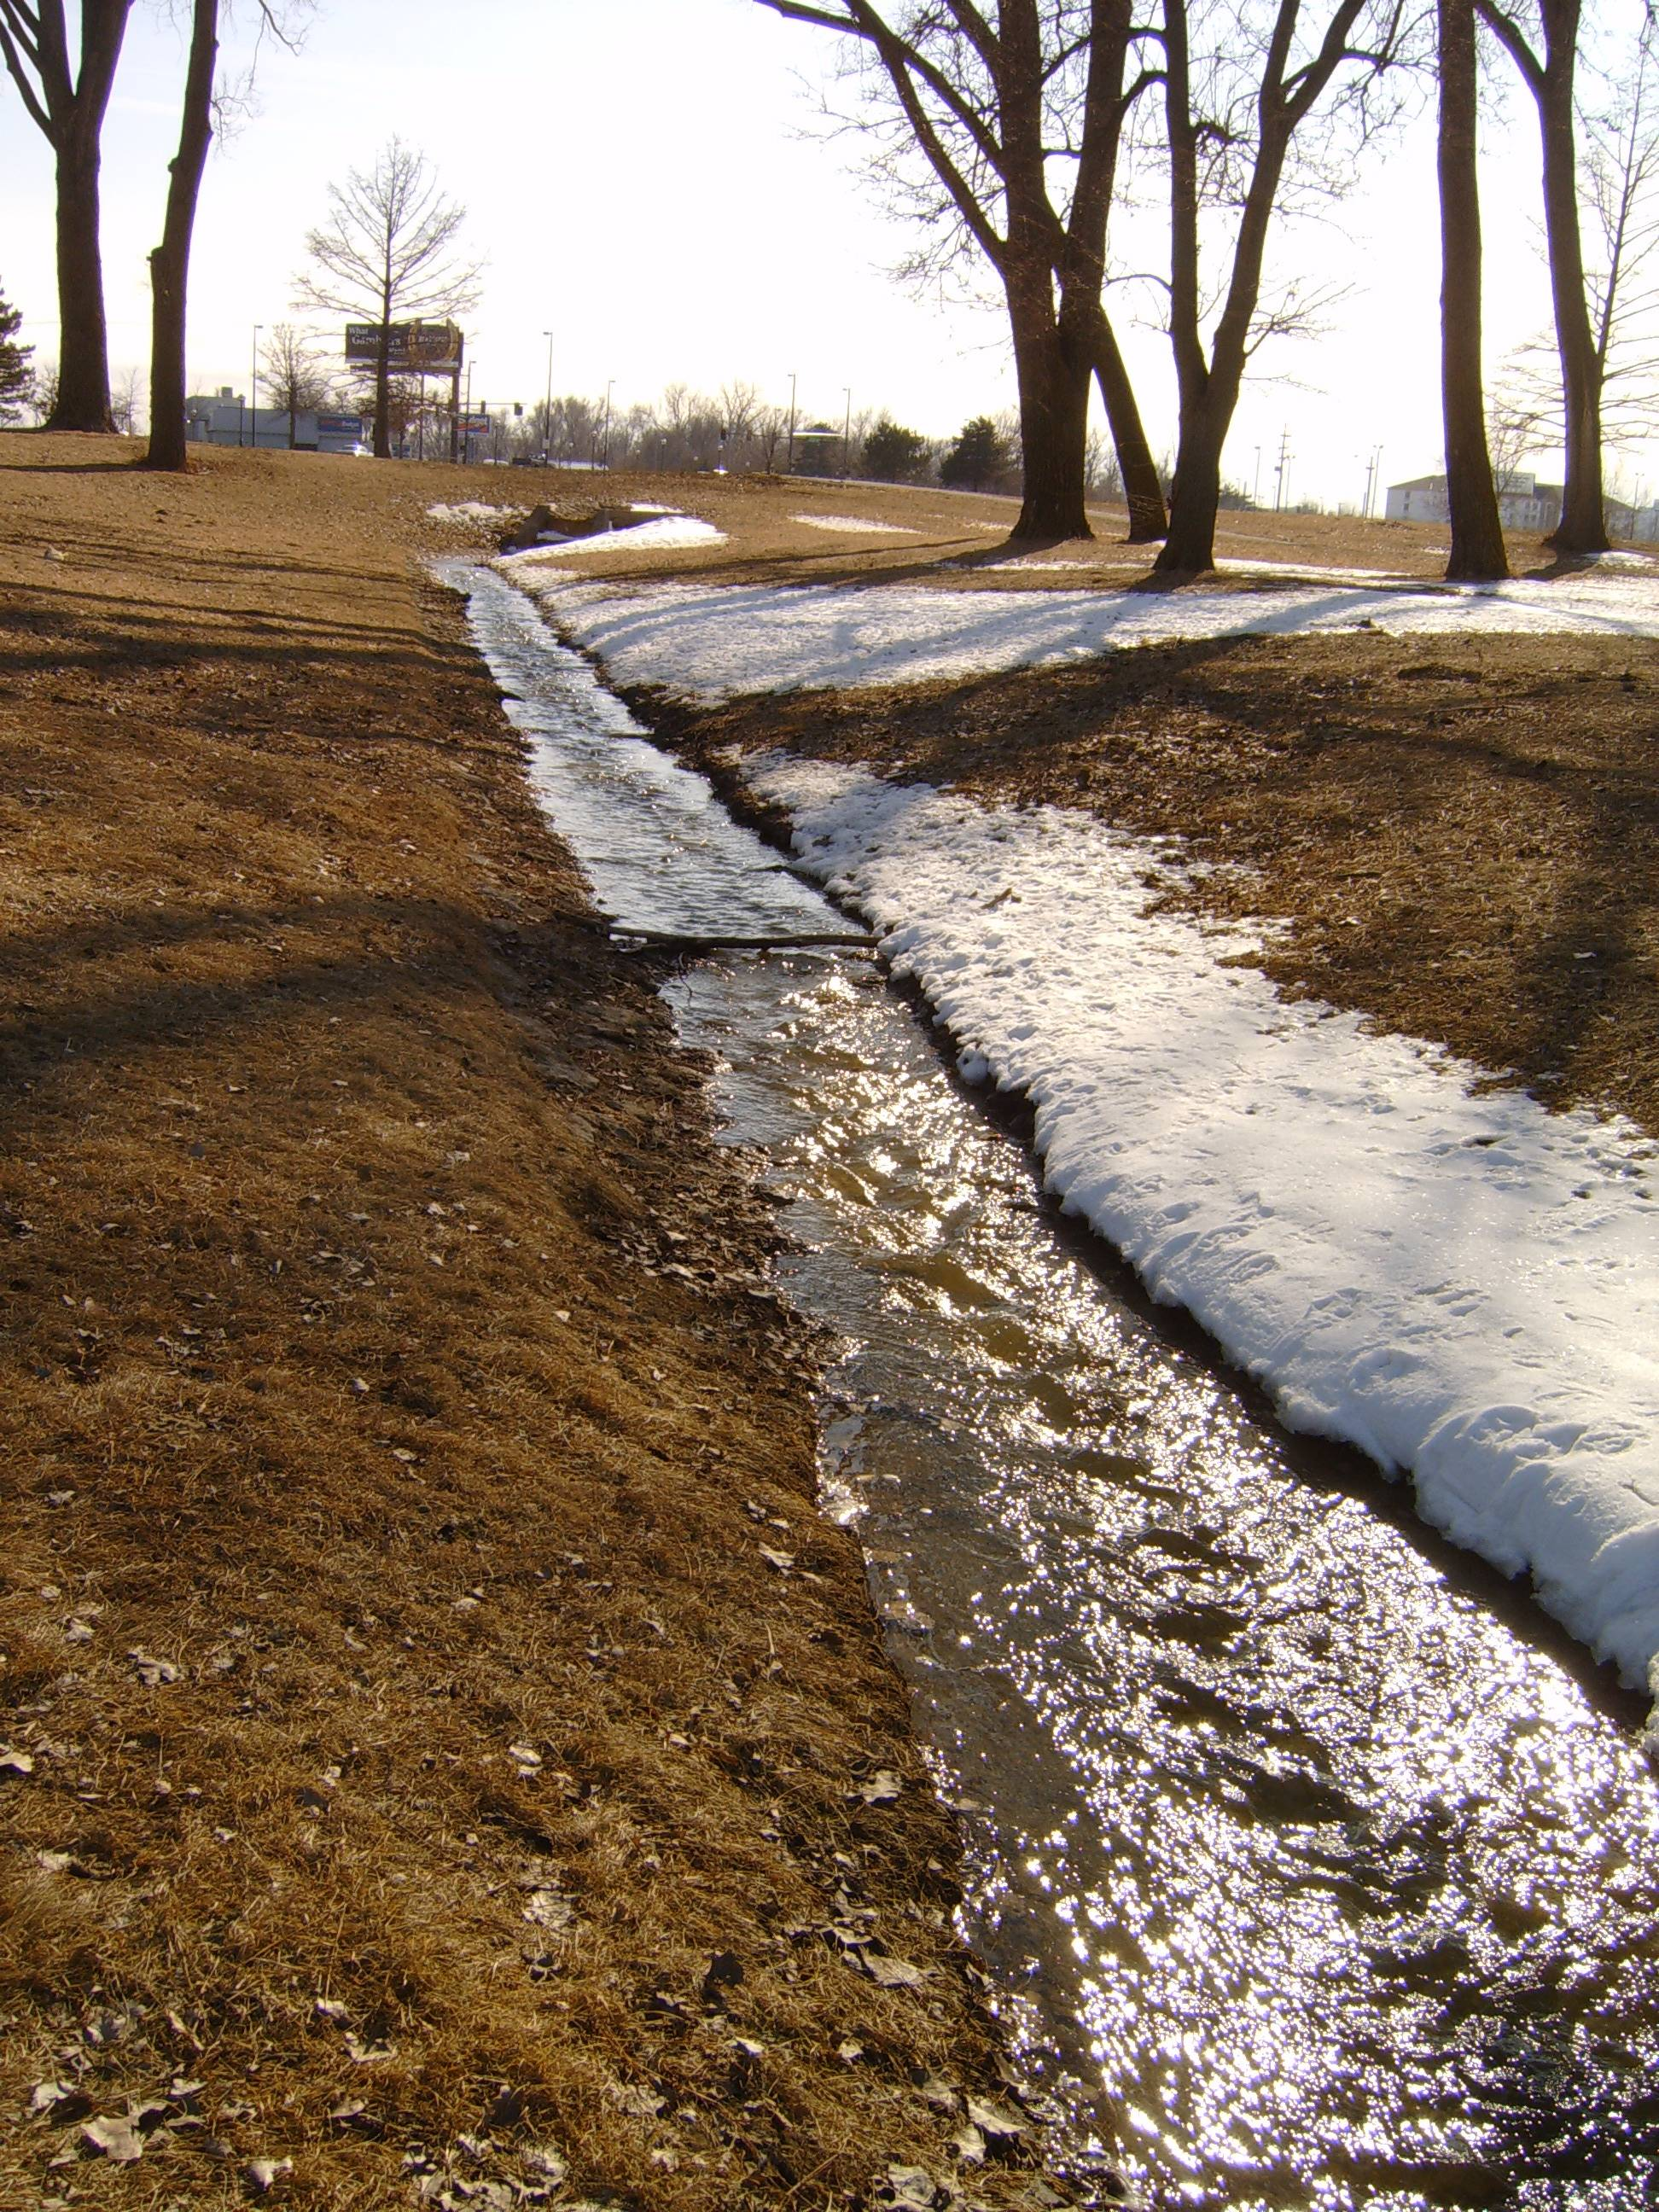
In 2007, the City of Omaha completed the improvements to the Kiwanis Park, pond and fountain.

The Carter Lake Preservation Society and the City of Carter Lake funded an Aquifer Test Analysis on the well that fills the pond.

The test indicated that 45% of well water obtained from induced infiltration of the lake.

The 1,000 gallons per minute pump is located in a well 900 feet from the lake.
Kiwanis Park Pond overflows to Carter Lake
How Much Water Does Carter Lake NEED?
Average Monthly Precipitation and Evaporation at Carter Lake
 | Rainfall | Evaporation | Net
January | 0.77 | 0.89 | -0.12
February | 0.91 | 1.04 | -0.13
March | 1.91 | 1.56 | 0.35
April | 2.94 | 2.08 | 0.86
May | 4.33 | 5.58 | -1.25
June | 4.08 | 6.26 | -2.18
July | 3.62 | 6.47 | -2.85
August | 4.10 | 5.58 | -1.48
September | 3.50 | 4.10 | -0.60
October | 2.09 | 3.35 | -1.26
November | 1.32 | 1.73 | -0.41
December | 0.84 | 1.12 | -0.28
Annual Totals | 30.4 | 39.76 | -9.35
Source: Section 22 Study Planning Assistance to States. Evaluation of Lake Levels for Carter Lake, Iowa Hydrology Analysis, August 1985

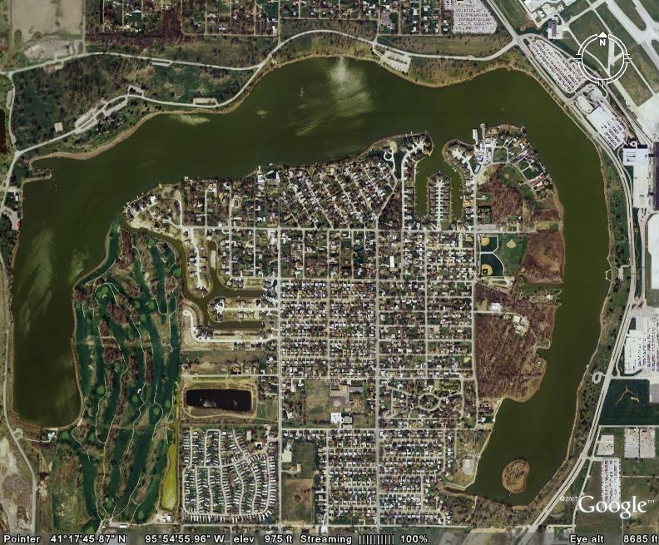
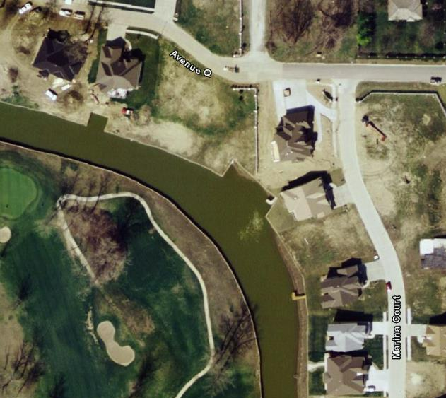
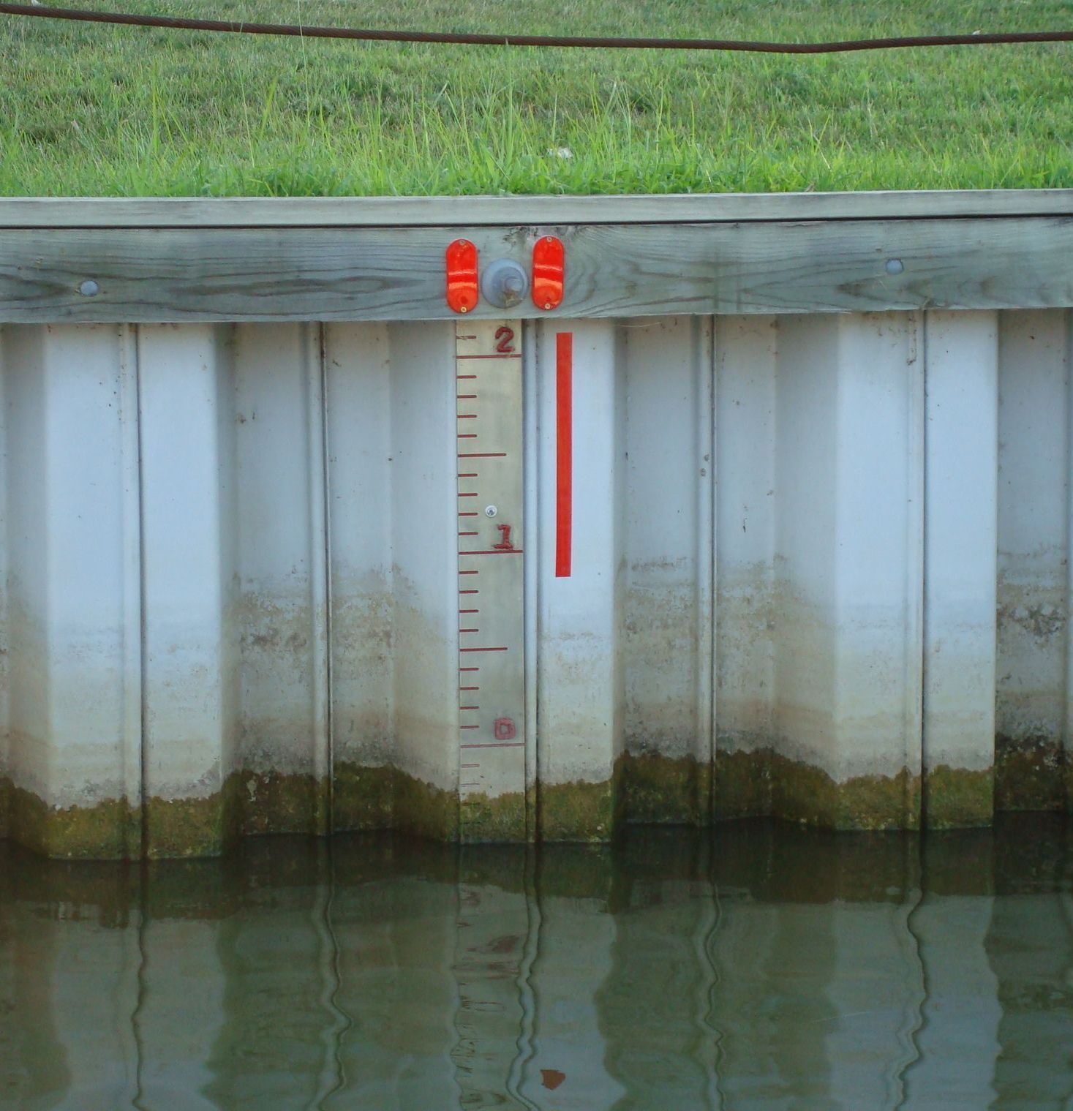
Where is the Lake Level Gauge?
Dock Street Site is the potential well location
- Location is relatively close to the river (400 feet) and close to existing infrastructure.
- Few sites are available - most property in the area is privately owned or in airport authority zone so other sites were considered too expensive or not available.
- Dock Street is owned by the City of Omaha.

CLPS permission to drill a test well from Omaha
- CLPS will fund test well to measure water quality and quantity ($10,000 est. cost).
- If test well results indicate the quality and quantity of water is positive, we plan to move forward with developing this into a permanent well for the recharge system.

Benefits of Dock Street Location
- The newly constructed well can be connected to the existing infrastructure.
- Will only need to run new pipe from the well to the connection point.
- Original project cost estimates will be reduced significantly.
- Complexity of the project is simplified and the time frame can be accelerated.
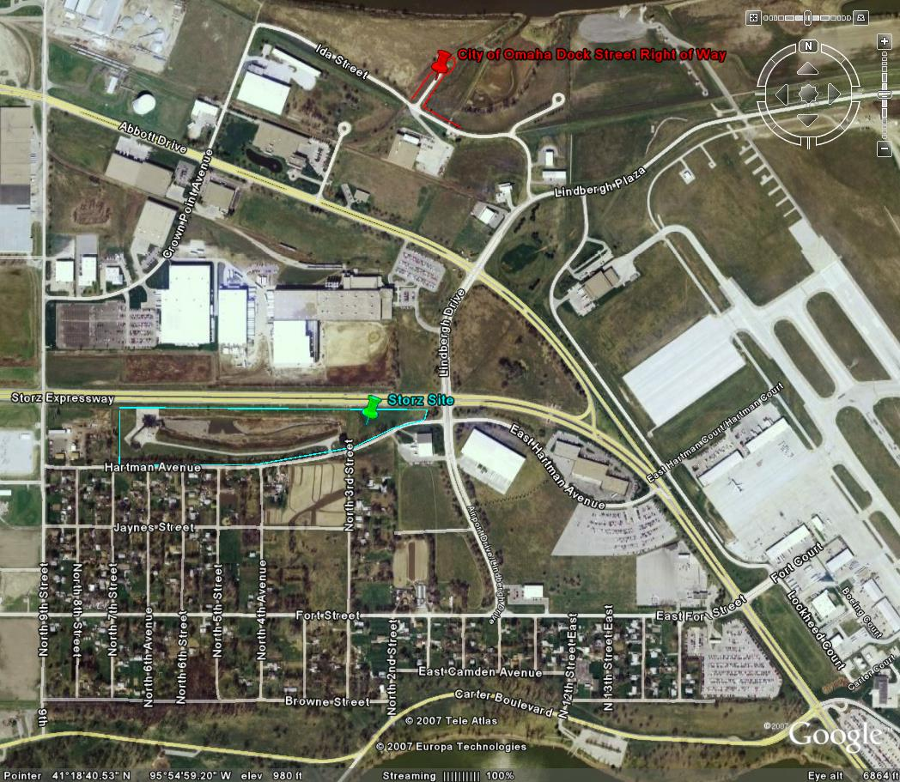
Location of Potential Well Site Near Dock Street

